ICB International Car Bridge
InterContinental Resort Al Ain, P.O. Box: 16031, Al Ain, UAE
Tel: 00971/50/7 13 13 07, Email: info@icbdubai.com
Kontakt in Deutschland: Volker Risse, Alfred-Ott-Str. 7, 53489 Sinzig bei Bonn
Tel: 02642/994999, Fax: 994997, Mobil: 0172/65 39 555
[[ NEW WEBPAGE: www.icbdubai.com & www.cartrader24.com ]]

Infiniti FX35 2WD und 4WD Neuwagen (Modell 2009) &
FX50 4WD Neuwagen (Modell 2009)

2009 New Infiniti FX35 RWD USA Specs

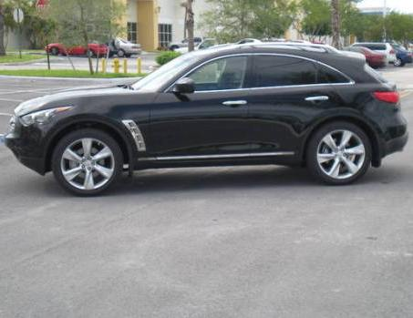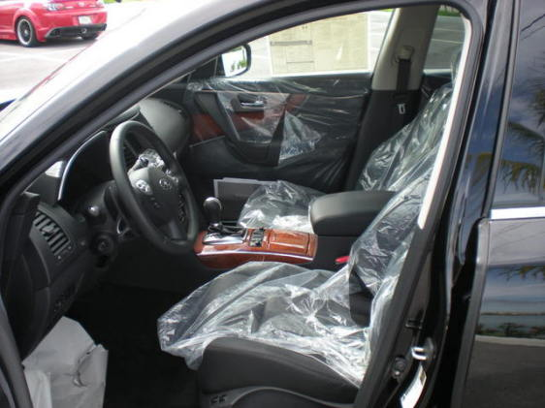

Features:

Summary
303-hp 3.5-liter V6 (FX35)
Rear Wheel Drive (RWD)
5-spoke, 18-inch aluminum-alloy wheels
High Intensity Discharge (HID) bi-functional xenon headlights
Leather-appointed interior
Infiniti Intelligent Key with Push Button Ignition
XM® Satellite Radio
Auxiliary audio input jack
Mechanical
3.5-liter V6 with 303 hp and 262 lb-ft of torque (FX35)
Electronically controlled 7-speed Automatic Transmission with Adaptive Shift Control (ASC) and Manual Shift Mode with Downshift Rev Matching (DRM)
Independent front double wishbone and independent rear multi-link suspension with Dual Flow Path shock absorbers and stabilizer bars
4-wheel ventilated disc brakes with Anti-lock Braking System (ABS), Electronic Brake force Distribution (EBD) and Brake Assist (BA)
Interior
Infiniti Intelligent Key with Illuminated Push Button Ignition
Dual Zone Automatic Temperature Control (ATC) system with microfiltration
Rear-seat heating and cooling vents in center console and heating ducts under front seats
Power windows with illuminated switches and front-window one-touch auto-up/down with auto-reverse feature
Power sliding glass moonroof with one-touch auto-open/close, tilt feature and sliding sunshade
Power door locks with auto-locking feature
Retained accessory power for windows and moonroof
12-point sequential welcome lighting illuminated entry system
Illuminated visor vanity mirrors
Overhead sunglasses storage
Dual overhead front map lights; rear-seat reading lights
Front seatback map pockets; front door pockets
Dual front and rear cup holders
Front armrest with dual-level storage compartment, 12-volt power outlet and auxiliary input jack
Rear-seat center armrest with storage compartment
Front and rear carpeted floor mats
Electric liftgate closure assist
Cargo net tie-down anchors in cargo area
Seating and Trim
Leather-appointed interior
8-way power driver’s seat, including 2-way power lumbar support; 8-way power front-passenger’s seat
Reclining rear seatbacks
Black lacquer interior trim
Leather-wrapped 3-spoke steering wheel and shift knob with aluminum accent
Stainless steel kick plate with Infiniti logo
60/40-split folding rear seatbacks; includes remote fold-down releases in cargo area
Audio System
11-speaker Bose® Premium Audio system with Burr-Brown DAC, AM/FM/CD with MP3 playback capability and Radio Data System (RDS)
In-dash, single-feed 6-disc CD autochanger
Auxiliary audio input jack
XM® Satellite Radio
Speed-sensitive volume control
Roof-mounted and in-glass diversity antennas
Steering wheel-mounted audio controls
Instrumentation and Driver Controls
Fine Vision electroluminescent gauges with chrome bezels
Tilt and telescopic steering wheel
Multi-function trip computer with outside temperature display
Infiniti Controller with 7-inch color LCD screen for audio, climate-control, fuel economy, maintenance and comfort and convenience features
RearView Monitor
Auto-dimming inside mirror with HomeLink® Universal Transceiver
Cruise control with steering wheel-mounted switches
Infiniti analog clock
Exterior
High Intensity Discharge (HID) bi-functional xenon headlights
Integrated front fog lights
LED taillights and center high-mounted stoplight (CHMSL)
Aluminum hood with gas strut supports
Scratch Shield paint
Integrated rear spoiler
UV-reducing tinted glass helps to reduce transmission of radiant heat to vehicle’s interior
Rear privacy glass
Rear window intermittent wiper and defroster with timer
Dual heated power-adjustable and folding outside mirrors
Front driver and passenger LED puddle lamps
Speed-sensitive flat-blade wipers
Dual chrome exhaust finishers
Side air vents
Safety - Accident Avoidance
Electronic Brake force Distribution (EBD)
Brake Assist (BA)
4-wheel Anti-lock Braking System (ABS)
Vehicle Dynamic Control (VDC)
Traction Control System (TCS)
Tire Pressure Monitoring System (TPMS)
Safety - Occupant Protection
The Infiniti Advanced Air Bag System (AABS) includes dual-stage supplemental front air bags with seat belt sensors and an occupant-classification sensor. When deployed, the inflation rate of these dual-stage air bags adjusts depending on crash severity and seat belt usage. If the front-passenger’s seat is empty, a sensor will deactivate the air bag
Front seat-mounted side-impact supplemental air bags
Roof-mounted curtain side-impact supplemental air bags with rollover sensor for front and rear-seat outboard occupant head protection
Front and rear head restraints for all occupant positions
Front-seat Active Head Restraints (AHR)
3-point height-adjustable front seat belts with pretensioners and load limiters, driver's seat Emergency Locking Retractor (ELR) and passenger's seat ELR and Automatic Locking Retractor (ALR)
Second-row 3-point seat belts with ELR and ALR
Slide-away brake pedal assembly moves brake pedal away from the driver in certain frontal collisions
LATCH System (Lower Anchors & Tethers for CHildren) helps simplify proper installation of compatible child restraint seats
Snug Kids offers recommendations for choosing and installing child restraint seats
Security
Remote keyless entry system with selective unlocking of driver's door or all doors
Infiniti Intelligent Key emergency backup slot to start vehicle if keyfob battery fails
First Aid kit
Infiniti Vehicle Immobilizer System embeds an encoded transponder chip into ignition key. The engine control computer will not allow the engine to start without the correct key and transponder
Remote power-opening of windows; closing via exterior door lock
Battery saver helps prevent accidental discharging if electrical accessories are left on
Vehicle Security System sounds alarm if intrusion is detected

nur US$45.500,- // Euro 30.333,- // Bruttoendpreis: 41.000,- Euro

2009 New Infiniti FX35 AWD USA Specs

Same specification like above, additionally:

Intelligent All-Wheel Drive (AWD)
5-spoke, 20-inch aluminum-alloy wheels

nur US$47.000,- // Euro 31.333,- // Bruttoendpreis: 42.630,- Euro

2009 New Infiniti FX50 AWD USA Specs

Same specification like above, additionally:

390-hp 5.0-liter VVEL V8 (FX50)
Intelligent All-Wheel Drive (AWD)
5-spoke, 20-inch aluminum-alloy wheels
5.0-liter VVEL V8 with 390 hp and 369 lb-ft of torque (FX50)
Quilted leather-appointed seating (standard on FX50; available on FX35)
Hand-stained Maple wood and piano black interior trim (standard on FX50; available on FX35)

Infiniti Hard Drive Navigation System with 8-inch color touch-screen, Lane Guidance, 3-D building graphics and XM NavTraffic® with Real-Time Traffic information (standard on FX50; available on FX35)
Aluminum roof rails (standard on FX50; available on FX35)

nur US$61.000,- // Euro 40.666,- // Bruttoendpreis: 54.500,- Euro

Additional Packages and Options
Deluxe Touring Package $2,850.00 optional on FX35
Premium Package $2,550.00 optional on FX35
Navigation Package $3,050.00 optional on FX35
Technology Package $3,100.00 optional on FX35 & FX50
Infiniti Mobile Entertainment System $1,800.00 optional on FX35 & FX50
Sport Package $3,200.00 optional on FX35 & FX50

U02 | Technology Package  Includes intelligent brake assist with forward collision warning, lane departure prevention and warning system, pre-crash seat belts, intelligent cruise control (full speed range), distance control assist, and rain sensing front wipers. FOR FX35 this REQUIRES U01.
U01 | Navigation Package  Includes an Infinity Hard Drive navigation system, voice recognition for HVAC, audio, and navigation, XM NavTraffic with real-time traffic information, 9.3GB music box hard drive with compact flash slot, 8" color touchscreen, sonar system (front and rear) and Around View Monitor (4 exterior cameras give you a 360 degree view on your in dash monitor). This unit replaces the 6-disc in-dash CD changer with single CD. REQUIRES P01.
G01 | Deluxe Touring Package  Includes 20" x 8" five-spoke, high luster metallic-finished wheels with 265/50 R20 all-season tires, adaptive front lighting system with auto-leveling front headlamps and genuine maple wood trim. REQUIRES P01.
P01 | Premium Package  Includes climate-controlled front seats, Bluetooth hands-free phone system, iPod connectivity, 2-position driver's memory seat, exterior mirrors w/ reverse tilt-down feature, power tilt/telescoping steering wheel, paddle shifters, aluminum pedals, quilted leather seats, roof rails, tonneau cover and cargo net.
R92 | Aero Kit (Late Availability)  NOT AVAILABLE with U02.
W93 | 18" Silver Painted Alloy Wheels (Late Availability)  NOT AVAILABLE with G01.
V01 | Infinti Mobile Entertainment System  Includes DVD player in front center console, 2 sets of wireless headphones, and 9.0-inch widescreen power fold-down display in the rear headliner. REQUIRES U02.
S01 | Sport Package  Includes 4-wheel steering, adaptive headlights, auto-leveling headlights, dark tinted headlights, sport seats, driver's seat with 4-way power bolster adjustment, thigh extensions for driver and front passenger seats, exterior side air vents and lower side trim, active suspension and Continuous Damping Control (CDC) driver adjustable suspension with "Normal" and "Sport" ride control settings.

Alle Preise netto inkl. Verschiffung und Transportversicherung frei CIF Hamburg (Kurs: 1Euro=1,50US$)

In Deutschland fallen folgende weitere Kosten an, die im Bruttoendpreis aber schon enthalten(!!) sind:

10% Zoll, MwSt., 350,- Euro Harbourhandling, 800,- Euro Fahrzeugbrief, 1.000,- Euro Umbau der Beleuchtungsanlage.

