ICB International Car Bridge
InterContinental Resort Al Ain, P.O. Box: 16031, Al Ain, UAE
Tel: 00971/50/7 13 13 07, Email: info@icbdubai.com
Kontakt in Deutschland: Volker Risse, Alfred-Ott-Str. 7, 53489 Sinzig bei Bonn
Tel: 02642/994999, Fax: 994997, Mobil: 0172/65 39 555
[[ NEW WEBPAGE: www.icbdubai.com & www.cartrader24.com ]]

Kia Opirus GL Modell 2009 Benziner Sonderangebot

- 3.8 Ltr, V6 DOHC Engine  - Steel Timing Chain  - Power – 263 HP @ 6000 rpm  - Torque – 36 Kg-M @ 4500 rpm  - 4 Wheel Disc Brakes  - Outside Mirror Mounted Side Repeaters  - Dual Muffler  - ABS with BAS  - Dual Airbags w Front Active Head Rests  - Front and Back Warning Sensor  - LED Turn Signals  - 235 / 55 R 17 Alloy Wheels  - Fog Lamps  - Auto Light Control  - Driver + Passenger power seats  - Steering Audio Remote  - Dual Zone Automatic Climate control Air conditioner  - Radio + 6CDC + MP3 Player + Infinity Speakers  - Auto Cruise Control  - Power Steering with Tilt  - 5-Speed-HMatic Auto Transmission | - Power Outer Mirrors with Folding Type  - Central Locking with Keyless Entry  - Electro Chromic Inside Rear View Mirror  - Driver Seat Electric Lumbar Support  - Wood Grain Interior  - In Glass Antenna  - Cabin Air Filter  - Blue Tooth  - Electronic Stability Program w Brake Assist System  - Traction Control System  - Leather seats  - Integrated Memory Seats  - Electronic Tilt and Telescopic Steering  - Woofer and Amplifier  - High Intensity Xenon Head Lamps  - Power Sliding and Tilting Sunroof  - Supervision Cluster  - Solar control glass  - Air Ionizer  - Large 5.5” travelling Info and Audio Monitor  - LED Type rear combination lamps

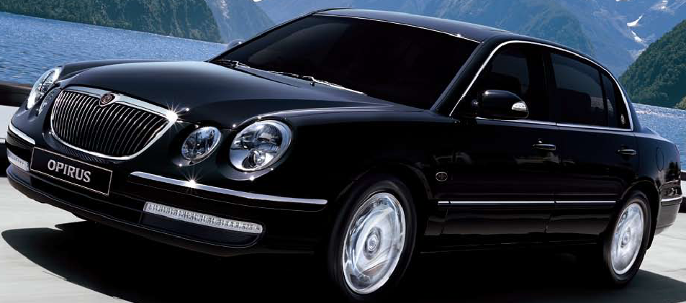
Colours Avialable
Exterior | Interior
B Silver | Black
B Silver | Grey
Black | Black
Black | Grey
Pearl White | Black
Pearl White | Grey

Sonderangebot solange Vorrat reicht:

nur US$ 23.250,- // Euro 15.500,- // Bruttoendpreis: 21.999 Euro

