ICB International Car Bridge
InterContinental Resort Al Ain, P.O. Box: 16031, Al Ain, UAE
Tel: 00971/50/7 13 13 07, Email: info@icbdubai.com
Kontakt in Deutschland: Volker Risse, Alfred-Ott-Str. 7, 53489 Sinzig bei Bonn
Tel: 02642/994999, Fax: 994997, Mobil: 0172/65 39 555
[[ NEW WEBPAGE: www.icbdubai.com & www.cartrader24.com ]]

New SORENTO Model 2010
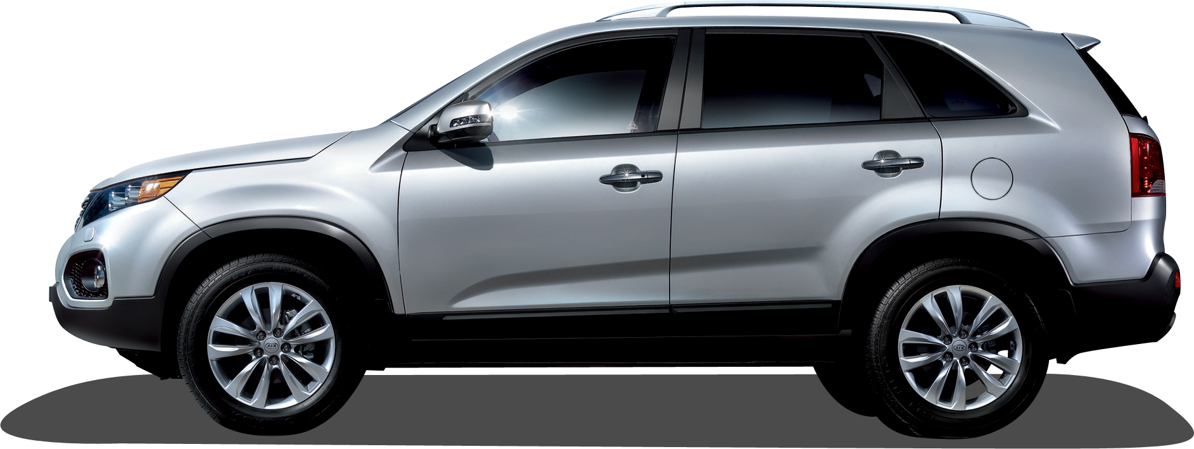

NEW SORENTO 2.4 LX PWR 4WD (MY – 2010)
- Roof Rack  - Black sill side molding  - Body Colour Outer Mirrors / Door Handles  - Chrome Radiator Grille & Rear Garnish  - 2.4 ltr. 4 Cyl, Dual C.V.V.T Engine  - Power: 172 HP / 6000 rpm  - Torque: 23 Kg.M /3750 rpm  - Steel Timing Chain  - Transmission: 6 Speed Sports Automatic  - 4Wheel Drive system: Active Torque on Demand  - Suspension Fr/Rr : McPherson Strut/ Multi Link.  - Back Warning Sensors  - Dual Airbags  - Anti Lock Braking System  - Brakes Fr/Rr: V Disc / Disc  - Fog Lamp  - 235 / 65 R 17 Alloy Wheels  - Front Seat Belts w/Pre tensioner and load limiter  - ELR Fixed Type rear seat belts  - Anti Corrosion treated body.  - Engine Cover & Hood insulator  - Front and Rear Air conditioners  - MP3 CD Player w/ 6 Speakers | - USB +Ipod Connectivity  - Micro Antenna  - (2+3+2) seating configuration  - 1St Row Seats  - Sliding & Reclining Seats w/Adjustable Headrests  - Driver Seat height adjuster  - 2nd Row Seats  - 60/40 Split Folding w/center armrest  - Adjustable Headrests  - 3rd Row Seats  - 50:50 Foldable Bench type for 2 Passengers  - Adjustable Headrests  - Blue tooth Mobile Phone Connectivity  - Trip Computer  - Power and Tilt steering  - Power Windows & Outside Side Mirrors  - Central Locking & Keyless Entry System  - Overhead console w/ sunglass storage & Map lamps  - Metal painted Center Fascia & inner door handles  - Digital clock & LCD Trip /Odometer  - Reverse camera with electro chromic mirror

US$ 23.300,- // Euro 17.920,- // Bruttoendpreis: 24.750 Euro

NEW SORENTO 2.4 EX PWR 4WD (MY – 2010)
- Roof Rack  - Black sill side molding  - Body Colour Outer Mirrors  - Chrome Radiator Grille & Rear Garnish  - 2.4 ltr. 4 Cyl, Dual C.V.V.T Engine  - Power: 172 HP / 6000 rpm  - Torque: 23 Kg.M /3750 rpm  - Steel Timing Chain  - Transmission: 6 Speed Sports Automatic  - 4Wheel Drive system: Active Torque on Demand  - Suspension Fr/Rr : McPherson Strut/ Multi Link.  - Back Warning Sensors  - Dual Airbags  - Anti Lock Braking System  - Brakes Fr/Rr: V Disc / Disc  - Fog Lamp  - Front Seat Belts w/Pre tensioner and load limiter  - ELR Fixed Type rear seat belts  - Anti Corrosion treated body.  - Engine Cover & Hood insulator  - MP3 CD Player w/ 6 Speakers  - USB +Ipod Connectivity  - (2+3+2) seating configuration  - 1St Row Seats  - Sliding & Reclining Seats w/Adjustable Headrests  - Driver Seat height adjuster  - 2nd Row Seats  - 60/40 Split Folding w/center armrest  - Adjustable Headrests | - 3rd Row Seats  - 50:50 Foldable Bench type for 2 Passengers  - Adjustable Headrests  - Blue tooth Mobile Phone Connectivity  - Trip Computer  - Power and Tilt steering  - Power Windows & Outside Side Mirrors  - Central Locking & Keyless Entry System  - Overhead console w/ sunglass storage & Map lamps  - Metal painted Center Fascia & inner door handles  - Digital clock & LCD Trip /Odometer  - Dual Front Auto AC w/ Clean Air Ionizer  - Panoramic Sunroof  - 235 / 60 R 18 Alloy Wheels  - Active Headrests  - Power Driver Seat  - Cruise Control  - Steering Audio remote  - Power folding outer mirrors  - LED Side Repeater on outer mirrors  - Leather wrapped steering Wheel & TGS Knob  - LED Rear Combination Lamp  - Black Side Garnish  - Front Illuminated Door Scuffs & Sun visors  - Rear Spoiler  - Chrome outer door Handles & Chrome accent-Air vent knob, Audio/Heater Dials, Cluster ring, Cupholder  - Micro Antenna

US$ 27.500,- // Euro 21.150,- // Bruttoendpreis: 28.900 Euro

NEW SORENTO 3.5 LX – PWR 4WD (MY – 2010)
- Roof Rack  - Black sill side molding  - Body Colour Outer Mirrors / Door Handles  - Chrome Radiator Grille & Rear Garnish  - 3.5 ltr. V6, Dual C.V.V.T Engine  - Power: 274 HP / 6300 rpm  - Torque: 34.2 Kg.M /5000 rpm Steel Timing Chain  - Transmission: 6 Speed Sports Automatic  - 4Wheel Drive system: Active Torque on Demand  - Suspension Fr/Rr : McPherson Strut/ Multi Link.  - Back Warning Sensors  - Dual Airbags  - Anti Lock Braking System  - Brakes Fr/Rr: V Disc / Disc  - Fog Lamp  - 235 / 65 R 17 Alloy Wheels  - Front Seat Belts w/Pre tensioner and load limiter  - ELR Fixed Type rear seat belts  - Anti Corrosion treated body.  - Engine Cover & Hood insulator  - Front and Rear Air conditioners  - MP3 CD Player w/ 6 Speakers | - USB +Ipod Connectivity  - Micro Antenna  - (2+3+2) seating configuration  - 1St Row Seats  - Sliding & Reclining Seats w/Adjustable Headrests  - Driver Seat height adjuster  - 2nd Row Seats  - 60/40 Split Folding w/center armrest  - Adjustable Headrests  - 3rd Row Seats  - 50:50 Foldable Bench type for 2 Passengers  - Adjustable Headrests  - Blue tooth Mobile Phone Connectivity  - Trip Computer  - Power and Tilt steering  - Power Windows & Outside Side Mirrors  - Central Locking & Keyless Entry System  - Overhead console w/ sunglass storage & Map lamps  - Metal painted Center Fascia & inner door handles  - Digital clock & LCD Trip /Odometer

US$ 25.900,- // Euro 19.920,- // Bruttoendpreis: 27.400 Euro

NEW SORENTO 2.2 Diesel EX 4WD (MY – 2010)

- 2.2 Ltr, CRDi Diesel Engine  - Power – 197 ps / 3800 rpm  - Torque – 44.5 Kg.M / 2500 rpm  - Steel Timing Chain  - Roof Rack  - Body Coloured Outer Mirrors  - Chrome Outer Door Handles  - Chrome Radiator Grille / Rear Garnish  - Back Warning Sensor  - Dual Airbags  - Anti Lock Braking System  - Front Fog Lamps  - 18 Inch Alloy Wheels  - Front and Rear Auto Air conditioner with Clean Ioniser  - MP3/CD Player w 6 Speakers  - Steering Audio Remote  - USB – I Pod Connectivity  - Trip Computer | - Blue tooth Mobile phone Connectivity  - Power Steering  - Power Windows and Mirrors  - Central door lock with Key Less Entry  - Over Head Console with Sunglass case  - 2+3+2 Seating configuration  - Active Head Rests  - Power Driver Seat  - Cruise Control  - Power folding rear view mirrors.  - LED repeaters on outside rear view mirrors.  - Rear Spoiler  - Panoramic Sunroof  - Chrome Accent air vent knobs, Audio/Heater dials, Cluster ring, cup holder.

US$ 30.400,- // Euro 23.380,- // Bruttoendpreis: 31.900 Euro

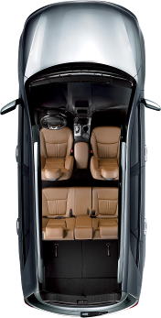
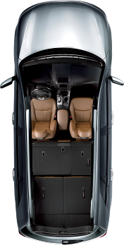
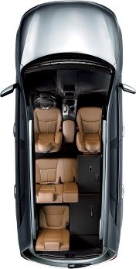
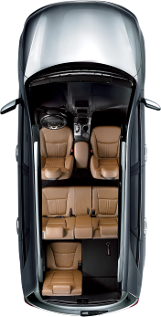
Lederausstattung (Farbe wählbar) und Sitzheizung gegen 1.990 USD Aufpreis möglich.

Alle Preise netto inkl. Verschiffung und Transportversicherung frei CIF Hamburg (Kurs: 1Euro=1,30US$)

In Deutschland fallen folgende Kosten an, die im oben genannten Bruttoendpreis schon enthalten sind(!!!):

10% Zoll, MwSt., sowie 1.700 Euro für Harbourhandling, Nachrüsten der Nebelschlußleuchte, Fahrzeugbrief

