ICB International Car Bridge
InterContinental Resort Al Ain, P.O. Box: 16031, Al Ain, UAE
Tel: 00971/50/7 13 13 07, Email: info@icbdubai.com
Kontakt in Deutschland: Volker Risse, Alfred-Ott-Str. 7, 53489 Sinzig bei Bonn
Tel: 02642/994999, Fax: 994997, Mobil: 0172/65 39 555
[[ NEW WEBPAGE: www.icbdubai.com & www.cartrader24.com ]]

New SORENTO Model 2010
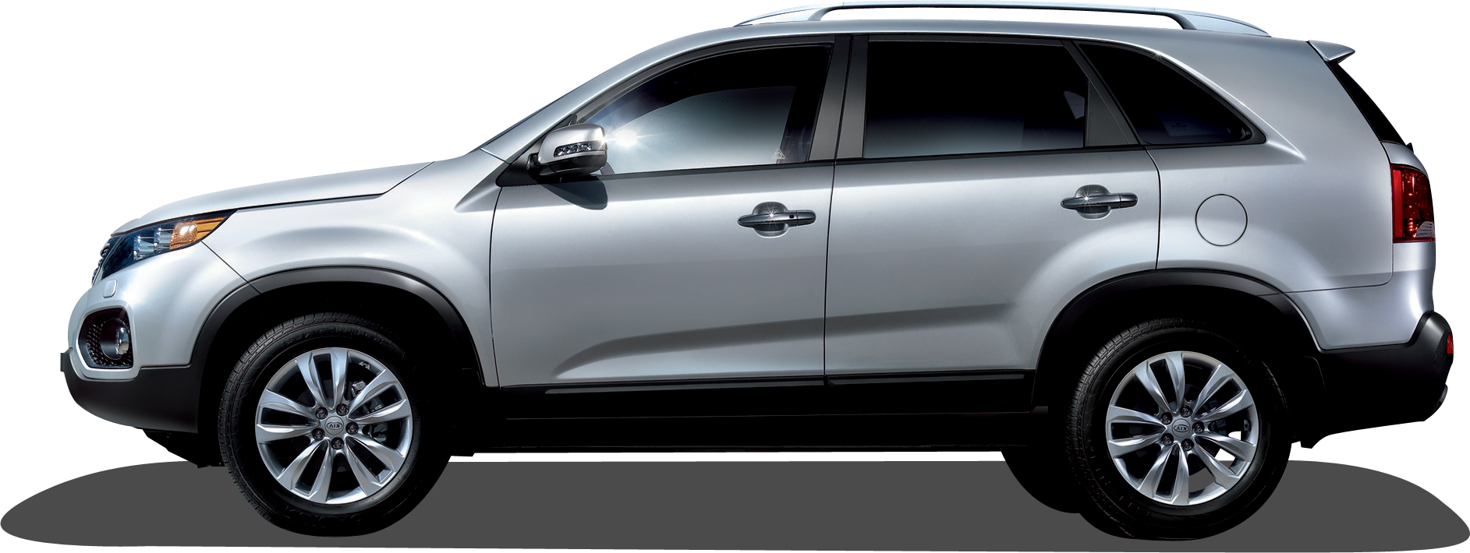

NEW SORENTO 2.4 LX – 7 Seater 4WD (MY – 2010)
- 2.4 Ltr, 4 Cylinder, Dual CVVT Engine  - Power – 172 HP / 6000 rpm  - Torque – 23 Kg.M / 3750 rpm  - 6 Speed Automatic Transmission  - Steel Timing Chain  - Roof Rack  - Body Coloured Outer Mirrors / Door Handles  - Chrome Radiator Grille / Rear Garnish  - Back Warning Sensor  - Dual Airbags  - Anti Lock Braking System  - Front Fog Lamps | - 17 Inch Alloy Wheels  - Front and Rear Air conditioner  - MP3/CD Player w 6 Speakers  - USB – I Pod Connectivity  - Trip Computer  - Blue tooth Mobile phone Connectivity  - Power Steering  - Power Windows and Mirrors  - Central door lock with Key Less Entry  - Over Head Console with Sunglass case  - 2+3+2 Seating configuration

US$ 26.900,- // Euro 18.550,- // Bruttoendpreis: 25.400 Euro

NEW SORENTO 2.4 EX – 7 Seater 4WD (MY – 2010)
- 2.4 Ltr, 4 Cylinder, Dual CVVT Engine  - Power – 172 HP / 6000 rpm  - Torque – 23 Kg.M / 3750 rpm  - 6 Speed Automatic Transmission  - Steel Timing Chain  - Roof Rack  - Body Coloured Outer Mirrors  - Chrome Outer Door Handles  - Chrome Radiator Grille / Rear Garnish  - Back Warning Sensor  - Dual Airbags  - Anti Lock Braking System  - Front Fog Lamps  - 18 Inch Alloy Wheels  - Front and Rear Auto Air conditioner with Clean Ioniser  - MP3/CD Player w 6 Speakers  - Steering Audio Remote  - USB – I Pod Connectivity | - Trip Computer  - Blue tooth Mobile phone Connectivity  - Power Steering  - Power Windows and Mirrors  - Central door lock with Key Less Entry  - Over Head Console with Sunglass case  - 2+3+2 Seating configuration  - Active Head Rests  - Power Driver Seat  - Cruise Control  - Power folding rear view mirrors.  - LED repeaters on outside rear view mirrors.  - Rear Spoiler  - Panoramic Sunroof  - Chrome Accent air vent knobs, Audio/Heater dials, Cluster ring, cup holder.

US$ 29.200,- // Euro 20.140,- // Bruttoendpreis: 27.400 Euro

SORENTO 2.2 EX -7Seater 4WD (MY–2010) - Diesel

- 2.2 Ltr, CRDi Diesel Engine  - Power – 197 ps / 3800 rpm  - Torque – 44.5 Kg.M / 2500 rpm  - Steel Timing Chain  - Roof Rack  - Body Coloured Outer Mirrors  - Chrome Outer Door Handles  - Chrome Radiator Grille / Rear Garnish  - Back Warning Sensor  - Dual Airbags  - Anti Lock Braking System  - Front Fog Lamps  - 18 Inch Alloy Wheels  - Front and Rear Auto Air conditioner with Clean Ioniser  - MP3/CD Player w 6 Speakers  - Steering Audio Remote  - USB – I Pod Connectivity  - Trip Computer | - Blue tooth Mobile phone Connectivity  - Power Steering  - Power Windows and Mirrors  - Central door lock with Key Less Entry  - Over Head Console with Sunglass case  - 2+3+2 Seating configuration  - Active Head Rests  - Power Driver Seat  - Cruise Control  - Power folding rear view mirrors.  - LED repeaters on outside rear view mirrors.  - Rear Spoiler  - Panoramic Sunroof  - Chrome Accent air vent knobs, Audio/Heater dials, Cluster ring, cup holder.

US$ 30.400,- // Euro 20.965,- // Bruttoendpreis: 28.990 Euro
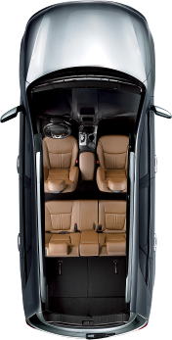
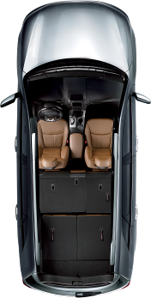
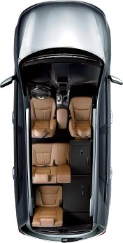
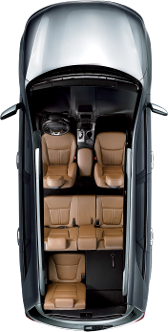
Lederausstattung (Farbe wählbar) und Sitzheizung gegen 1.990 USD Aufpreis möglich.

Alle Preise netto inkl. Verschiffung und Transportversicherung frei CIF Hamburg (Kurs: 1Euro=1,45US$)

In Deutschland fallen folgende Kosten an, die im oben genannten Bruttoendpreis schon enthalten sind(!!!):

10% Zoll, MwSt., sowie 1.700 Euro für Harbourhandling, Nachrüsten der Nebelschlußleuchte, Fahrzeugbrief
