ICB International Car Bridge
InterContinental Resort Al Ain, P.O. Box: 16031, Al Ain, UAE
Tel: 00971/50/7 13 13 07, Email: info@icbdubai.com
Kontakt in Deutschland: Volker Risse, Alfred-Ott-Str. 7, 53489 Sinzig bei Bonn
Tel: 02642/994999, Fax: 994997, Mobil: 0172/65 39 555
[[ NEW WEBPAGE: www.icbdubai.com & www.cartrader24.com ]]

Nissan PickUp Double Cabin Modell 2008 Benziner & Diesel, 2WD & 4WD Neuwagen

SPECIFICATIONS

Model | : | Nissan Pick-up Benziner 2WD 5-Gang-Schaltgetr.
Description  Price | :  : | Double Cab STD Petrol 4x2  15.950USD/10.220Euro (Brutto: 15.290 Euro)
Body Type | : | Pick-up
Exterior Dimensions | : | 5,080 x 1,690 x 1,620 (l x w x h) mm
Wheelbase mm | : | 2,950
Min Ground Clearance | : | 190 mm
Seating Capacity | : | 1+5
Engine | : | 4-cyl, in-line DOHC, Petrol, EFI
Displacement cc | : | 2,389
Max Power hp/rpm | : | 160 / 5,600
Max Torque kgm/rpm | : | 22.2 / 3,600
Transmission | : | 5 Speed Manual Transmission
Steering | : | Power, Re circulating Ball Type
Fuel Tank Capacity | : | 75 litres
Suspension Front | : | Independent double wishbone torsion bar type, with telescopic shock absorbers.
Rear | : | Semi-elliptic Leaf springs, with telescopic shock absorbers.
Brakes Front | : | Ventilated Discs
Rear | : | Drums, with auto adjuster
Tyres | : | 195 R 15
Features

- Air Conditioner
- Digital Clock
- Radio Cassette Player
- Cloth Upholstery
- Rear Step Bumper
- Halogen head lamps
- Green tinted windshield
- Side door impact beams
- Cloth Upholstery
- Rear Step Bumper
- Non dazzle rear view mirror
- Remote fuel lid opener

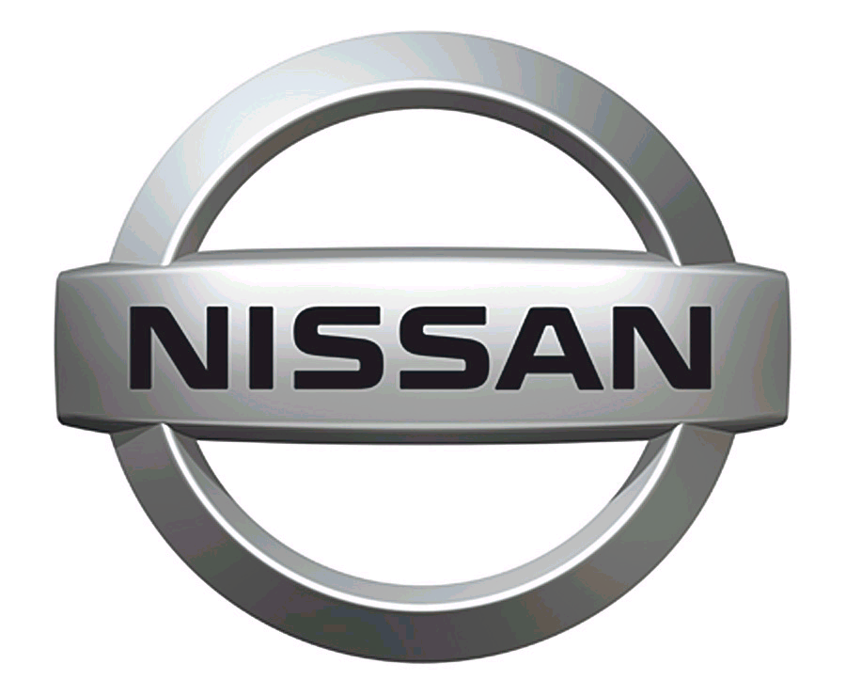 SPECIFICATIONS
Model | : | Nissan Pick-up Diesel 4WD, 5-Gang-Schaltgetriebe
Description  Price | :  : | Double Cab DX Diesel 4 x 4, 2008 MY  18.990USD/12.170Euro (Brutto: 17.610 Euro)
Body Type | : | Pick-up
Exterior Dimensions | : | 5,075 x 1,825 x 1,715(l x w x h) mm
Wheelbase mm | : | 2,950
Min Ground Clearance | : | 190 mm
Seating Capacity | : | 1+5
Engine | : | Diesel, 4-cyl, in-line OHV
Displacement cc | : | 2,500 turbo with intercooler
Max Power | : | 133 / 4,300 hp/rpm
Max Torque | : | 31 / 2,200 kg.m/rpm
Transmission | : | 5 Speed Manual Transmission
Steering | : | Power Assisted, Re-circulating Ball Type
Fuel Tank Capacity | : | 75 litres
Suspension Front | : | Independent double wishbone torsion bar type with telescopic shock absorbers.
Rear | : | Semi-elliptic Leaf springs with telescopic shock absorbers.
Brakes Front | : | Ventilated Discs
Rear | : | Drums, with auto adjuster
Tyres | : | 205 R 16
Other Features:

- Air Conditioner
- Digital Clock
- Radio Cassette Player
- Cloth Upholstery
- Rear Step Bumper
- Halogen head lamps
- Green tinted windshield
- Side door impact beams
- Cloth Upholstery
- Rear Step Bumper
- Non dazzle rear view mirror
- Child safety locks
- Front & rear mud guards

Nissan PickUp Double Cabin mit ABS und Doppelairbag kosten als Benziner und als Diesel: 21.950USD / 14.070Euro / Bruttoendpreis: 20.150Euro

Nissan PickUp Single Cabin kosten als Benziner: 14.990USD / 9.600Euro / Bruttoendpreis: 14.370Euro

Nettopreis inkl. Verschiffung und Transportversicherung frei CIF Hamburg zahlbar in US Dollar (Kurs: 1Euro=1,56US$). Beachten Sie den ungewöhnlichen aktuellen Wechselkurs. Der Dollar ist schwach, der Euro stark. Das macht den Kauf zur Zeit besonders günstig!!!

In Deutschland fallen folgende weitere Kosten an: 10% Zoll, MwSt., 350,- Euro Harbourhandling, 250,- Euro Nachrüsten der Nebelschlußleuchte, 350,- Euro Fahrzeugbrief

Wir liefern ebenfalls zu Sonderpreisen: Kia Sorento und Sportage (nur Benziner), Ford Mustang, Nissan Murano, Pathfinder & Armada, Infiniti FX35, FX45 & QX56, Lexus RX350, Toyota Land Cruiser Benziner & Diesel (HZJ105). Alle Preise und Ausstattungslisten online unter: www.icbdubai.com

Mit freundlichen Grüßen

Volker Risse
Sales Executive Europe

