TECHNICAL PROPOSAL – PATIENT TRANSPORTER AMBULANCE

Main wheeled transporter

Main stretcher with safety belt The stretcher is mounted
on the floor with rail and locking system. Tubular aluminium
construction provides durability & strength. This cot adjusts
to six height levels. Adjustable backrest angle from 0◦ to 75◦
allows patient to be positioned during transportation.
Two patient restraints ensure maximum safety of the patient
during transport. One of the lightest lift-in cot in the industry,
easily installed in ambulance.
Maximum Height: 85 cm
Minimum Height: 32 cm
Maximum Length: 193 cm
Overall width: 58 cm
Weight (without mattress) 29 kg
Load limit: 180 kg
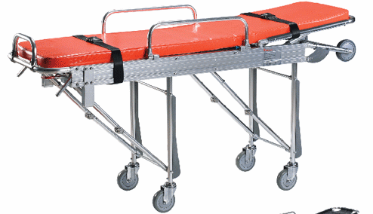
Folding Stretcher

Aluminium Alloy Folding Stretcher
Stretcher Opened:
Approx. 2000(L) x 550(W) x 150(H)mm
tubes: Approx. Dia. 30 x 1.5mm Carrying Capacity:
Approx. 150Kg.
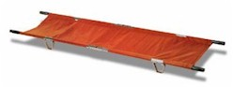
--------------------------------------------------------------------------------------------------------------------------------------
Patient compartment storage units and interior
All units to be designed specifically for the quoted vehicle which will incorporate all equipment and medical items listed in this specification.
Material: We will use integral form material which is perfect to be used in an Ambulance or any medical environment, it is easy clean and hygiene friendly
--------------------------------------------------------------------------------------------------------------------------------------Sphygmomanometer
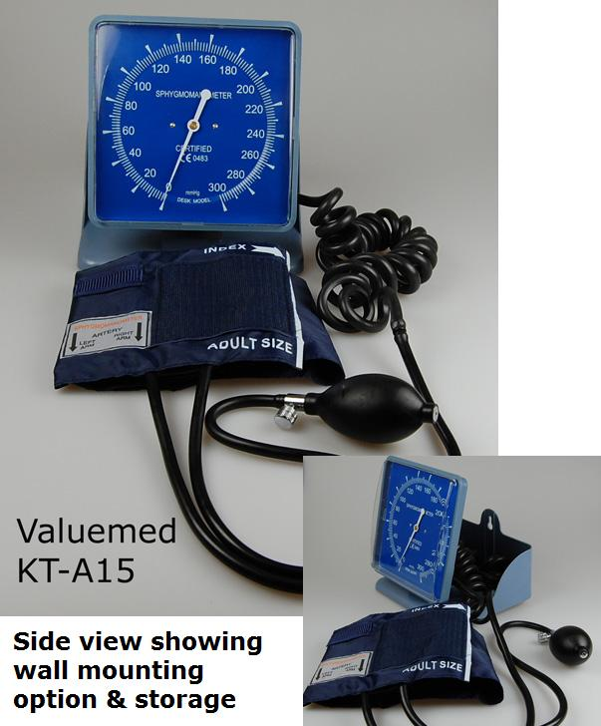
--------------------------------------------------------------------------------------------------------------------------------------Stethoscope
--------------------------------------------------------------------------------------------------------------------------------------
Electrical
Various sockets to be included 12v and 220 v
To be fitted with a power inverter which will distribute the electrics in order to incorporate plugs, emergency lighting etc and to be powered with the correct voltage
Roof lights for patient compartment
Air conditioning system in patient compartment
Light bar
Siren public speaker system and amplifier
2 Square type strobe lights on the front of vehicle
Rear Projector Scene light
Roof ventilation extractor
2 rotating lights on rear of roof
--------------------------------------------------------------------------------------------------------------------------------------
First aid kit complete:
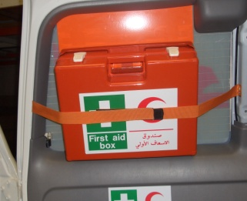
2 PIC 3 Box with:3 towellettes w/ disinfectants
2 towellettes w/ ammonium hydroxide 4%
3 hygenic soap pouches
2 adhesive plaster rolls M.5 x 1.25cm
1 pack of gauze bandages
5 packs of sterile gauze cm. 10x10 12 folds
5 packs of 25 pcs sterile gauzes cm 10x10
5 cotton wool packs GR.50
6 safety pins
4 triangular bandages TNT cm.96 x 96 x 136
1 pair of scissors 10cm
2 sterile tweezers
1 disposable sterile scalpel
1 haemostatic lacet
8 hypodermic syringes cc. 5 w/ towelettes
1 plastic kidney dish
4 eco splints 22cm
1 pack of 20 adhesive plasters
-------------------------------------------------------------------------------------------------------------------------------------------------------------------------
Oxygen Cylinder with bracket with regulator fitter with equipments for vehicular instillation qty 2 big and 1 small
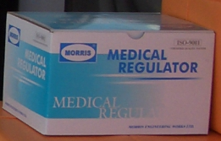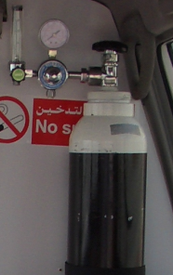
-------------------------------------------------------------------------------------------------------------------------------------------------------------------------
IV Hooks
-------------------------------------------------------------------------------------------------------------------------------------------------------------------------
Flooring to be covered witn wood then polyurethane vinyl sheeting – Automotive type vinyl for extra safety
-------------------------------------------------------------------------------------------------------------------------------------------------------------------------
Window between driver cabin and patient compartment
------------------------------------------------------------------------------------------------------------------------------------------------------------------------
Portable Suction unit
------------------------------------------------------------------------------------------------------------------------------------------------------------------------
2/3 (depending on vehicle) seat attendant bench with 3 point seat belts and flip up seat with hydraulic hinges which will allow additional storage space
Head immobilizer with adjustable straps for adult and baby rescue operations.
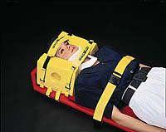

------------------------------------------------------------------------------------------------------------------------------------------------------------------------
Manual Resuscitator
Ambo set with adult mask
Hand operated, compressible self refilling ventilation bag with non-rebreathing patient valve with pressure limitation valve to minimize the risk of over inflating, intake valve with nipple for oxygen tubing. Supplied with oxygen reservoir bag (suitable capacity) and 1 meter oxygen tubing. Resuscitator can be disassembled for cleaning, disinfecting or autoclaving process.
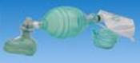
-------------------------------------------------------------------------------------------------------------------
Intercom System for communication between driver and patient compartment. Hands free system
-------------------------------------------------------------------------------------------------------------------
2 Fire extinguishers
-------------------------------------------------------------------------------------------------------------------
Cervical Collar Adjustable
-------------------------------------------------------------------------------------------------------------------
PORTBLE SEARCH LIGHT
-------------------------------------------------------------------------------------------------------------------
Oxygen Masks Adult and pediatric – x 2
---------------------------------------------------------------------------------------------------------------------------------------------------------
Syringes various sizes full set
---------------------------------------------------------------------------------------------------------------------------------------------------------
--------------------------------------------------------------------------------------------------------------------------------------------------------
Sharps Container for biomedical waste
--------------------------------------------------------------------------------------------------------------------------------------------------------
Fire extinguishers 2 in the front and 2 in the patient compartment
--------------------------------------------------------------------------------------------------------------------------------------------------------

Suction Unit -

