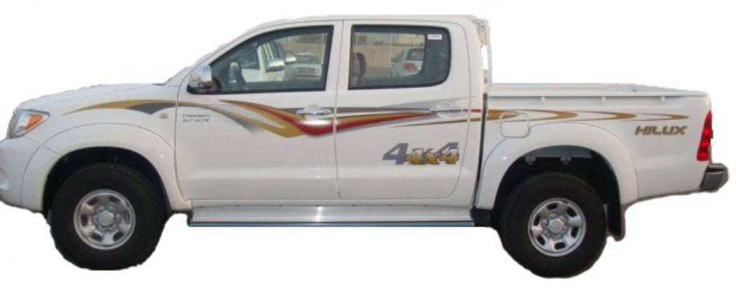
ICB FZE, PO Box: 16031, Al Ain, UAE, Kontakt in D: Volker Risse, Alfred-Ott-Str.7, 53489 Sinzig, Tel: +49-2642-994999, volker@icbdubai.com
Engine Type 2.5Ltr, 4Cyl, 16V, DOHC, Turbo Diesel, Common-rail
Power & Torque 100HP, 26.5Kg-m
W/O Top shade for Windshield glass









ABS
D+P Airbags
Additional features over HILUX 4WD D/C 2.7 DLX PWR
Additional features over HILUX 4WD D/C DSL DLX PWR
Additional features over HILUX 4WD D/C DSL DLX P/S
HILUX 4WD D/C DSL DLX P/S
TECHNICAL
Additional features over HILUX 4WD D/C 2.7 DLX P/S
HILUX 4WD D/C 2.7 DLX PWR A/T
Additional features over HILUX 4WD D/C 2.7 DLX PWR
Toyota HILUX 2010 4X4
HILUX 4WD S/C 2.7 DLX P/S
22.200$/14.800€ / Bruttoendpreis: 20.980€
 Body dimensions (mm) 5255 x 1760 x 1795 mm
 Deck dimensions (mm) 2315 x 1520 x 450 mm
 Wheel Base 3085mm
 Engine Type 2.7Ltr, 4 Cyl, 16 V, DOHC, EFi, VVTi engine
 Power & Torque 158HP, 24.6Kg-m
 Suspension Fr/Rr: Double Wishbone/ Leaf spring
 Brake V.Disc/Drum & LSPV
 Fuel tank capacity 76 Ltr
 Tire 205R16 tires
 Power & Tilt steering HILUX 4WD D/C 2.7 DLX PWR+A/B+ABS
EXTERIOR
 Bumpers: Colour keyed (Fr)/ Chrome (Rr)
 Chrome Outside Door handles/ Outer Mirrors 24.700$/16.466€/Bruttoendpreis: 23.400€
 Flat type rear bumper (Chrome)  ABS
 Headlamps: Multi-reflector, Halogen  D+P Airbags
 J type deck  Fr. Seat belts with Pre-tensioner
 Mudguards: Fr & Rr + Side Step INTERIOR
 Spare Tire Lock  Front Separate Seats
 Top shade for Windshield glass  Rear Console Box
 Wheel Cap: Centre Ornament type  W/O Instrument panel upper tray
SAFETY
 Front seat belts: 3PELRx2+2PNRx1
INTERIOR
 Adjustable Fr. Seat belt anchors
26.050$/17370€/ Bruttoendpreis: 24.800€
 Air conditioner & Heater + Clean Air Filter  Transmission 4-speed A/T
 Audio: AM/FM ETR Cassette 2 Speakers  Drive Train Auto Disconnecting Differential (ADD)
 Cup holder + Digital Clock + Glove Box with Key INTERIOR
 Foot rest for Driver  Front Separate Seats
 Front seat: 40:60 split type  Rear Console Box
 Fuel Lid Opener
 Inner rear view mirror: Day/ Night type
 Sunvisors: D+P (D with Holder)
 Tachometer
 Urethane Steering Wheel & Shift lever knobs

HILUX 4WD D/C 2.7 DLX P/S
Additional features over HILUX 4WD S/C 2.7 DLX P/S
23.300$/15533€/ Bruttoendpreis: 22.200€ HILUX 4WD D/C DSL DLX PWR
 Body Type Double cabin model
 Body dimensions 5255 x 1760 x 1820 mm
 Deck dimensions 1520 x 1515 x 450 mm TECHNICAL
EXTERIOR Body dimensions 5255 x 1835 x 1820 mm
 Side stripe Tire 255/70R15 tires
 W/O Side step EXTERIOR
SAFETY Overfenders - Colour keyed
 Rear Seat Belts: 3PELRx2+2PNRx1  Side step
INTERIOR  Power Door lock + Outer Mirror + Window
 Instrument panel upper tray  Fabric Door trim
 Rear Headrests: 2 pc
 Rear seat: 3 persons (Tip-up type) HILUX 4WD D/C DSL DLX PWR+A/B+ABS
HILUX 4WD D/C 2.7 DLX PWR
Additional features over HILUX 4WD D/C 2.7 DLX P/S
24.600$/16.400€ / Bruttoendpreis:23.500€
24.000$/16.000€ / Bruttoendpreis: 22.800€
 Body dimensions 5255 x 1835 x 1820 mm  Fr. Seat belts with Pre-tensioner
 Tire 255/70R15 tires INTERIOR
EXTERIOR  Front Separate Seats
 Overfenders - Colour keyed  Rear Console Box
 Power Door lock + Outer Mirror + Window  W/O Instrument panel upper tray
 Side step
INTERIOR
 Fabric Door trim Kurs: 1€ = 1.50US$

